TASC WELCOME PACK 2023/24

WELCOME TO TOWERBANK AFTER SCHOOL CLUB
Thank you for choosing TASC! We look forward to caring for your child and we promise to do our best to keep them happy and healthy!
Our Priority is to provide Play And Care of the Highest Standard

We hope this pack will answer most of your questions,
please get in touch if you have more!

WHO ARE TASC?
We are a parent run, non-profit making registered childcare provider based in Towerbank Primary School. We are not run by the school so please contact us directly not through the school office!

I am Becky, the Manager of TASC and responsible for the running of the Club. I am usually at After School Club sessions Monday to Thursday and always happy to chat to parents and carers. At other times you can contact me by email on becky.tasc@gmail.com
I run TASC as an open and friendly Club and always welcome communication with our families – so don’t be afraid to ask anything!
Lisa and Joyce (L-R) are my deputies and are very experienced senior staff at TASC. If I am not in Club, they are responsible for day-to-day activities. You can contact them via our club email tasc49@gmail.com or our club phone 07796597976 during club hours. Please use this phone number to let us know if your child will be absent or any day-to-day issues.

Elaine is our administrator and you will get to know her well via email. Elaine deals with all our registrations, fees and waiting lists etc. She will send you regular invoices and you can always ask her any questions about fees or bookings – she is very friendly and efficient!
She prepares all our registers and will be the person you should contact if you need to change your regular booking. She works Monday to Wednesday afternoons, so please don’t expect a reply out of these hours. Her email is elaine.tasc@gmail.com

Our dedicated regular staff team of Playworkers are (L-R below) Amie, Haris, Heather, Kim, Sharon, Simrit and Sophie. They look forward to getting to know your child well and facilitating lots of fun play activities, as well as serving healthy and tasty snacks.

We also have some bank staff who may work occasionally: currently Matty, Tina and Tyree (L-R below) help us out when they are able and we need them.

Sometimes we need to use cover staff from a regulated and trustworthy agency and we also welcome safely recruited volunteers or students on placement so you may see other adults at TASC from time to time. If you are unsure, please just ask a member of our regular staff.

We have a board of Trustees/Directors who are all parents who use our service. This Board is elected every year at the AGM and they meet regularly to oversee the running of the Club and to keep all our policies updated.

The current Board is Carla Bichan (Chair), Matthew Gilbert-Straw (Secretary), Fiona Oberheim and Nic Robertson – new members are always welcome!

CAN I VISIT TASC BEFORE MY CHILD STARTS?
By all means! We are very happy to welcome visitors, by appointment and invite all new members to come for a visit. Drop me an email becky.tasc@gmail.com and we will arrange a time for you to pop in for a chat and for your child to see what happens at TASC. A good time is about 4.30pm Monday-Thursday as children have usually settled into activities by then.

HOW DO I FIND TASC?
We have a regular Let from Edinburgh Council to use Towerbank Primary School’s dining halls, plus the middle hall on the first floor and another classroom. We have occasional use of the gym hall when it is not being used by the Active School programme. We always have use of the playground.
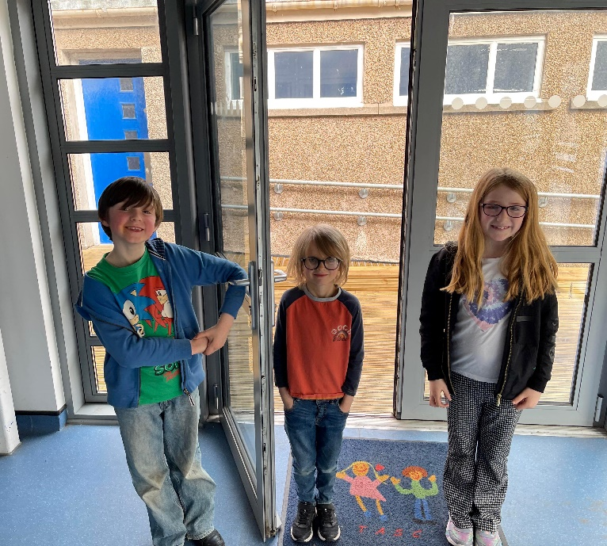
Please drop off or pick up your children from our entrance directly onto the dining hall, (part of the new extension) on the right of the school (as you look at the sea). Come right down past the P1 classrooms, with the nursery play area on your right. There is a doorbell for you to use if we are busy and don’t see you. Often we will be in the playground at pick up time, especially in the Spring/Summer months but there is usually a group of children playing inside so don’t panic if you can’t see your child! If you don’t see anyone and can’t get our attention with the doorbell we may be all in the gym hall (or perhaps out and about, especially if it’s a holiday club day) so just call the club phone 07796597976

HOW WILL YOU CARE FOR MY CHILD?
We try to get to know your child as well as we can – we create personalised care plans for each child based on the information you give us and we add to this any observations, special conversations and issues that may arise. If there are any additional needs such as medical issues or support needs, any extra information or strategy documents are kept in their care plan.

We follow current Play Work principles in our care, where children are encouraged to create their own play choices, supported by our staff. We offer a range of activities both indoors and outdoors and choices within the snack menu which vary from day to day. Children are offered healthy and appealing snacks and fresh fruit is always available.
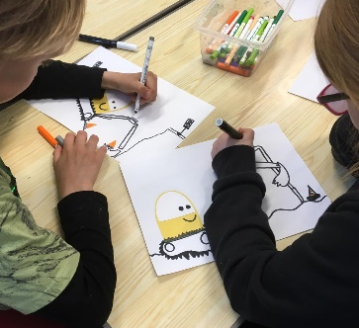
We have a wide range of free-play activities from active games outdoors to crafts, board games, construction and imagination play indoors. There are always books and drawing/art materials and staff are happy to read to children or help with creative activities. We are always aware that our Clubs run outwith school time and as such fun and relaxation are our goal, not formal learning or overly directed activities.

Sometimes we have music playing or will relax with a movie and some of the older children have occasional access to digital tablets but every day children will be playing traditional and non-screen based games and activities.

We constantly look for feedback from children and their families so please let us know what you think, and any new activity ideas are very welcome!

We will always be supervising your child’s play. As we don’t want to interfere in the children’s play unless they need/want us to we may be at a distance and not directly interacting with the children, but we are looking out for children who may be alone or unhappy or keeping an eye for any dangerous/anti-social play, when we will of course intervene. If children would like an organised or adult-led game or activity, we can provide this too. We have a minimum ratio of 1-10 adults to children (1-8 during Holiday Clubs) but for most sessions there are usually more adults than our legal minimum. We have a maximum of 80 children at After School Club and 30 at Breakfast Club. (Holiday Club limits depend on staffing and outings)

We are informed by the Getting it Right for Every Child Scottish government framework which states that care settings should be working to ensure that children are: Safe, Healthy, Achieving, Nurtured, Active, Respected, Responsible, and Included.

MY CHILD HAS A MEDICAL ISSUE OR ADDITIONAL SUPPORT NEEDS, HOW WILL TASC PROVIDE WHAT THEY NEED TO BE SAFE AND HEALTHY?
We ask for details of any medical, allergy or behavioural issues (such as neuro-diversity) on our initial registration form and we rely on parents/carers to give us as much information as possible so that we can make strategies to care for your child’s individual needs.

We ask for parent’s permission to also speak to Towerbank Primary School staff if we feel it would be helpful in getting a broader picture of the support your child needs. This can help us to ensure that their care is consistent across all their care settings.

Where a child needs regular or precautionary medication, we need to hold this at TASC as well as at school. The school office cannot share medication with us and it closes before TASC so in an emergency we need our own medication to hand. We understand that it can be hard to get extra prescriptions for multiple inhalers etc but we need to ensure that your child can receive the emergency treatment they may need as soon as possible. Please ensure that all medication is brought in and signed for by TASC staff before your child’s first session. We will not be able to take your child for a session if you have stated a medical issue but not provided the relevant medication.

We keep your child’s medication safely in labelled bags and record all expiry dates. You will receive a courtesy reminder email in the month before an expiry date to give you time to get new medication. If anything changes, please let us know immediately.

We check all our food and drinks each session against our list of stated allergies and intolerances (as well as preferences) to ensure that your child is not given something that could put them in danger.

Please give us as much information about any allergies/intolerances as you can, for example “milk allergy” can mean a number of things – can the child have cooked dairy in a cracker or no traces at all? Could they have a reaction if they sit next to a child drinking milk or are they fine with some cheese or yoghurt but not milk itself? We have a variety of needs to cater for so appreciate as much information about your child as possible. We have a regular rotating snack menu so we are very happy to share this for you to check products.

With any medical or allergen issue please give us as much detail as you can about what might trigger symptoms and what signs to look out for if they are having a reaction or a medical attack, so that we can ensure they receive help and treatment as soon as possible.

We will always call you, but may call 999 first if there is a serious emergency.

If your child needs short term medication administering (eg anti-biotics) we will need you to fill out a form with the doses, timings and how to store the medication along with your permission for us to give the medication.

If in doubt talk to us!

WHAT DO YOU NEED FROM ME AS PARENT/CARER?
Good communication is key in helping us to care for all our children. Here are some things that help us enormously:

- Text, call or email us directly (not the school office) if your child is going to be absent 07796597976 or tasc49@gmail.com

- Sign up to and read my regular email newsletters (they can end up in spam/junk folders so please check regularly). They often contain important information. Please sign up via our webpage www.towerbankafterschoolclub.org.uk/newsletter/

- Let us know as much as you can about your child – what they like or don’t like, and particularly about any medical or behavioural issues. The more informed we are, the better we can care for your child. If any of your core information changes, especially contact details or medication, please let us know as soon as possible.

- Please pay your fees as promptly as you can. We are not profit-making and all fees go towards paying staff, and equipment and activities for the children. We recommend setting up a standing order for your monthly amount for 11 months. Elaine will let you know this figure, once you are offered a place. You can use childcare vouchers to pay for all TASC clubs.

- If your child is going to be picked up by someone other than their named parent/key contact please let us know in advance. We can’t let your child go with someone we don’t know.

- Please let us know if your child will be attending another club eg an Active Schools club during a TASC session so that we can ensure that they go and are picked up safely.

- If your child is P5 or over and you would like them to go home independently we need a form filling out with your consent and instructions. Let us know if you require this.

- Please pick up your children in good time and please don’t drop them off early for a morning session. Late fees apply for late pick-ups. We are no longer insured after our stated hours, the school is locked up and it is upsetting for the children, plus some of our staff have bus journeys home and/or their own children to care for, so we really appreciate you being on time! (5.45pm Mon-Thurs and Holiday clubs, 5.30pm Fridays)

- Keep communication open and give us regular feedback on any issues so that we can keep improving.

Thank you!
HOW DO I TRUST THAT YOU ARE PROPERLY REGULATED AND TRAINED?
We are registered with and regulated by the Care Inspectorate and inspected regularly. All our staff are also individually regulated by the SSSC (Scottish Social Services Council) who stipulate a level of training all staff must attain. This includes regular statutory training in areas such as Child Protection, First Aid and Food Hygiene, plus other areas to maintain professionalism and good practice. There is also a level of qualification that all staff must achieve to maintain their membership of the SSSC.

We are fully insured and receive support and training through LAYC (Lothian Association of Youth Clubs) and Youth Scotland.

We have both Charity Commission and Registered Business numbers and are listed on the relevant regulatory websites.

All our staff and volunteers are safely recruited and we are an equal opportunities employer, paying the Real Living Wage to our staff.

WHAT ARE THE FEES?
Our current fee structure is:
One off Registration Fee per child £15.00
Cost per session:
Breakfast Club £4.40
Afterschool Club (Mon – Thurs) £9.40
Afterschool Club (Friday) £14.40
Holiday Club* £31.00
*Please note, depending on the activities planned on the day your child is booked in, there may be an additional surcharge of no more than £5.00 to pay. This will be advised when the Holiday Club schedule is published.

Our fees are reviewed each year and the Board may decide on an incremental increase to reflect inflation and increases in the Real Living Wage for staff, but this is always balanced by our desire to be an affordable childcare option. Any changes will be communicated in advance to families.

WHAT DOES A NORMAL TASC SESSION LOOK LIKE?
AFTER SCHOOL CLUB:
At the end of the school day, the P1 children are picked up directly from their classes. The other children need to go to our staff who are waiting in the shelter in the playground with the register. They then head to the cloakrooms near the dining halls to hang up their things and wash their hands. They can then choose to have a snack straightaway (most children do!) or there will be toys/games to play with if they’re not ready.

The children are in 3 age-based cohorts indoors (P1&2’s, P3&4’s and P5,6&7’s). This enables staff to get to know children better and to supervise them with more accuracy and attention, plus activities can be differentiated according to suitability for age.

Once most children have had snack, staff will offer to take children outside (unless the weather is too bad or it’s too dark). We encourage outdoor play for all children if possible as it is great for them to get fresh air and exercise after a long day at school, but we are aware some children want a quieter experience indoors and where we can, we will accommodate this.
Each week, we will encourage all children to have a go at a particular craft activity (seasonally linked if appropriate) but otherwise play is directed by the children themselves. Sometimes the gym hall becomes available later in the session so we may play some active indoor games there too.

A second snack (usually fruit) is offered later in the session but if children are hungry they can ask for something. We are a nut-free setting and all children’s allergies/intolerances are checked each day.

Children can be picked up at any time before 5.45pm when we close.

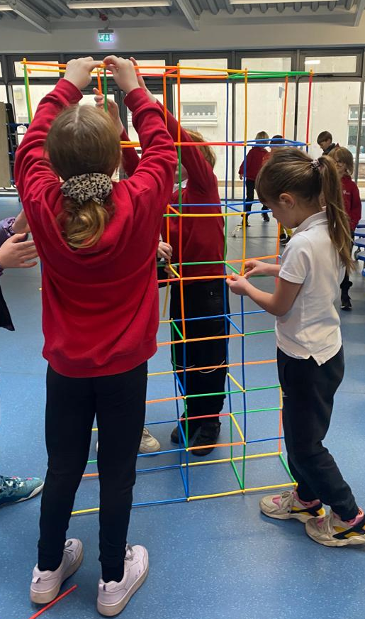
BREAKFAST CLUB
Children arrive at our entrance from 8am and after hanging up their things and washing hands they are offered breakfast. Breakfast is available as a rolling snack until 8.30pm.
The rest of the space in the dining room is set up with board games, drawing and other activities. Whilst we sometimes play more active games and a group may play outside if the weather is good, generally we encourage quieter play to prepare for the day at school.
Children are then taken to their classes for the start of the school day.

HOLIDAY CLUB
A planned programme of activities is advertised in advance and places are booked for each holiday club (we run Summer, October, February and Easter holiday clubs).
Children can arrive from 8.45am and there is usually plenty of time for free play both indoors and outdoors, from arrival and especially on club-based days but there are also the specific advertised activities which are more directed as well as planned outings. Information will be shared beforehand. A breakfast type snack will be offered soon after arrival and we also provide an afternoon snack, but children bring their own nut free lunches and lots of drinking water. Parents/carers can pick children up any time (unless we are out and about) but the sessions end at 5.45pm (or 1.15pm for a morning session).

MY CHILD IS A NEW P1 - WHAT CAN THEY EXPECT?
Starting at TASC as a new P1 (or in the Summer before) can be a little bit of a culture shock for some children (and their parents!) who may be used to nursery care.

We do everything we can to help all our new children to settle in as quickly as possible and we have a higher concentration of staffing working with our youngest children. However, the levels of independence expected are higher than in a nursery setting. Children need to be able to independently learn to find their way to the toilet, wash their hands and change by themselves. They need to be able to follow instructions given by staff, such as collecting and wearing coats or sunhats, drinking water when reminded or applying suncream when asked (with help).

We are aware that children can be at different stages of independence at this stage, for example younger siblings can find it much easier. Most new P1’s quickly adapt, though for some the noisy older children and the big old school building can take a little getting used to! Please speak to us if you feel your child may particularly struggle with the new start as there are often changes that can be made to help your child to settle, such as introducing them for a short amount of time at first. We would advise against a parent staying with a child as this doesn’t usually help a timid child and can unsettle other children.

We find that a few sessions at our Summer Club can really help with the big transition to school and after school club, as it’s a smaller group and an informal setting. However, we ask that you do not book them into trips and would recommend an early pick-up. We will keep an extra eye out for pre-P1 children at Summer Club but do remember it’s not nursery and they will need to come with a certain level of independence and be able to cope with some potentially boisterous older children!

Once the school let you know start dates for your child in August, please let us know when you would like your child to begin at TASC, as P1’s usually start school later than the rest of the children.

We very much look forward to getting to know you and your child.
We hope they have lots of fun at TASC!

