TASC Self-Evaluation for Improvement Strategy February 2023
Health and Social Care Standards 4.19 'I benefit from a culture of continuous improvement, with the organisation having robust and transparent quality assurance processes'

We are always looking to improve our ongoing self-evaluation, auditing and monitoring process across all areas of TASC. This will lead to us developing a more rigorous and systematic approach, using local and national guidance, to evidence and assess the delivery of our services and feed into the continuous improvement plan. This will enable us to be constantly assessing, evidencing and reflecting on our service delivery, as well as engaging the children, service users, the staff team and wider stakeholders in the ongoing improvement of TASC.

The Aim
Our aim is to know we are delivering childcare to a high standard while constantly challenging our ongoing and future practice so we can make informed and information driven decisions about how to improve our service and make a positive difference to people’s lives by delivering better outcomes.

The diagram below illustrates the process we are following:
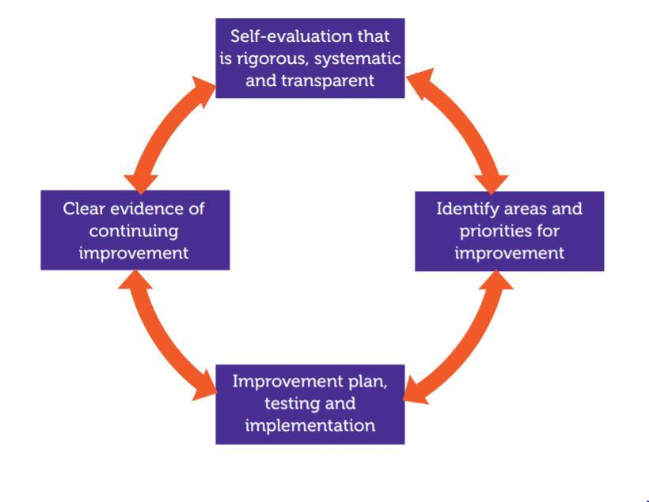
Self-Evaluation that is rigorous, systematic and transparent

What do we do? – Aims and Objectives
How do we do it? - Policy, Processes and Procedures
How do we know how we are doing? – Monitoring, Evaluation and Feedback

We will assess our current practice across the business including these key areas:

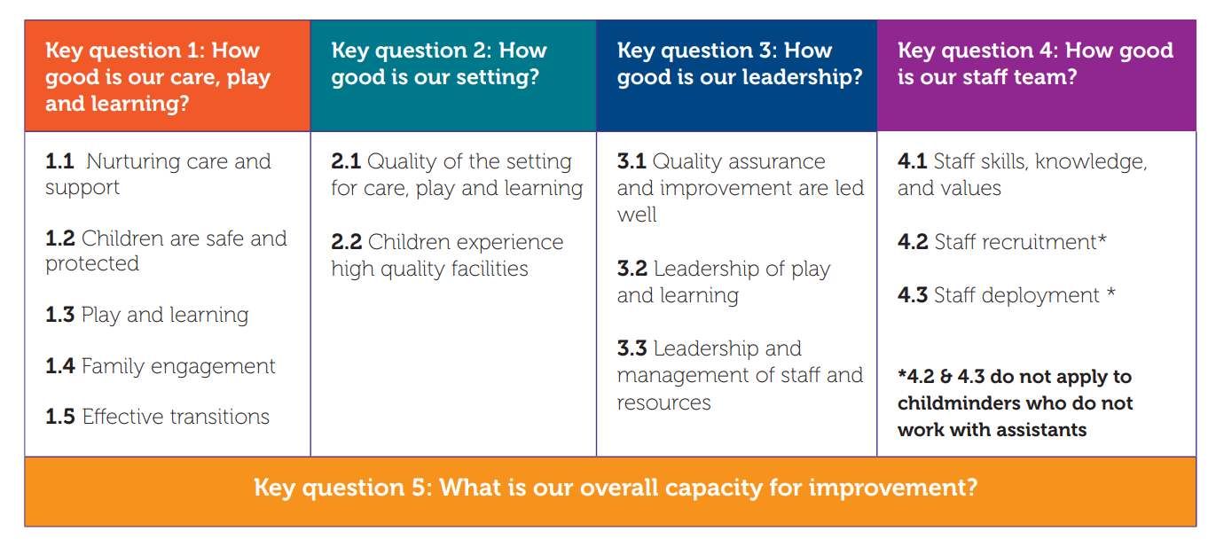

This process will include a triangulation of qualitative and quantitative data, people’s views and feedback, direct observation of practice and evidencing documentation through various means including:
- Regular, planned staff meetings and daily staff briefings including intentional self-evaluation.
- Staff Inset training and self-evaluation days at least twice a year.
- Staff appraisals/supervision meetings every 6 months.
- A shared Calendar which has key dates and schedules for self-evaluations.
- A parent and guardian survey once a year.
- Regular, ongoing open communication with parents, utilising key calendar dates to elicit feedback and ideas for improvement.
- A range of child focused engagement programmes.
- A monthly auditing checklist to develop a culture of reflective practice.
- A schedule for Child Care Plan Reviews and Policy Reviews (all child care plans reviewed every 6 months, all policies reviewed annually).
- The development of a representative group to meet annually to evaluate specific areas of work and advise on improvement priorities.
- The regular meetings and work of the Board of Trustees in supervising management.
- Diarise spot checks across all areas of the care service.

All of these actions can be evidenced and processes are now in progress or being initiated based on the Self Evaluation Plan (example attached).
Identify Areas and Priorities for Improvement
We will use the diarised prompts, team meetings, committee and Improvement group to highlight the areas/issues identified and agree what the priorities are. We will then consider who we need to involve, and think about any guidance, research, good practice examples, change ideas and other support we might need and move on to the planning, testing and implementation phase.

This will be focussed and selective so that we can ensure we have the time, budget and resources required to implement improvements and not become overwhelmed, lose focus or lose the team’s motivation and buy into the process.

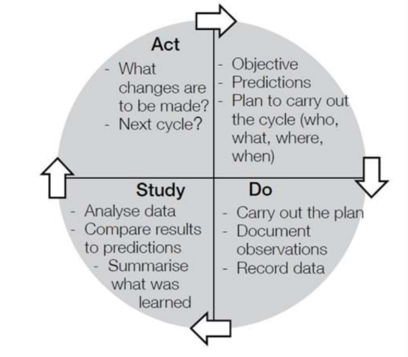
Improvement Plan, Testing and Implementation.
Once we have identified where a change needs to be made we will use the Model for Improvement
Plan, Do, Study, Act (PDSA) cycles will help us make rapid change through testing and implementation.

Clear Evidence of Continuing Improvement
How do we know we are improving?
Good, transparent and honest record-keeping and monitoring will help to maintain a cycle of continuing improvement. Initially improvements will be implemented and improvement measures will be assessed.

Once the improvement has been assessed it will become part of ongoing delivery and the relevant measures to ensure we are achieving the desired outcomes will move across to the Self Evaluation Plan. Inclusion of all staff in the improvement process is vital to ensure changes are embedded in day to day delivery. We will ensure we communicate to all those involved so that they are aware of amends, new processes and changes in delivery and understand why the improvements are being implemented as well as any responsibility they have within the process.

We are creating a culture that:
- Celebrates successes.
- Focuses on monitoring and evaluation of the service we provide.
- Provides ongoing, supportive, transparent leadership with clear communication.
- Keeps everyone informed and involved.
- Embeds continuous improvement into the culture of our service.
- Establishes a local network to share knowledge, learning and ideas.
- Delivers high quality services which are continuously improving.

Self Evaluation Plan

Area of the Service | Process/Policy/ Activity | Objectives | Measurements | Timings | Actioned | Improvements/ Development Required
 |  |  |  | Annually
 |  |  |  | Every month
 |  |  |  | Weekly

Example of Continuous Improvement Plan

Issue/ Area of Improvement | Objectives | Action | Responsibility | Desired Outcome and Evaluation | Timings | Next Action
 |  |  |  |  | Introduced by xx | No further action
 |  |  |  |  |  | Move to Self-Evaluation Plan
 |  |  |  |  |  | Next stage of development

